**CS2402 Assignment 2 Feedback**

**Marks: 95**

You have done a good job. The program runs smoothly. Please keep it on. Don’t overstress yourself and take a good rest before you start your next assignment! Happy studying!

All the marking work runs on MinGW 8.1.0 in Windows. If you have any question or require any further clarification please contact me [Shuaifang.Wang@usq.edu.au](mailto:Shuaifang.Wang@usq.edu.au).

**Question 1**

|  |  |  |
| --- | --- | --- |
| Marking Criteria | Full Marks | Your Marks |
| Program structured and documented | 2 | 2 |
| Use of input and menu system implementation | 3 | 3 |
| Function definitions, design | 7 | 7 |
| Parameter passing no global variables | 8 | 8 |
| Use of Arrays in the solution | 5 | 5 |
| Correct working solution and requested output | 5 | 5 |
|  | 30 | 30 |

**Question 2**

|  |  |  |
| --- | --- | --- |
| Marking Criteria | Full Marks | Your Marks |
| Program structured and documented | 5 | 5 |
| Function definitions, parameter passing | 6 | 6 |
| Parameters passing avoiding updates | 4 | 4 |
| Use of conditional branching looping | 2 | 2 |
| Use of Arrays processing in the solution | 5 | 5 |
| Correct working solution and requested output | 8 | 8 |
|  | 30 | 30 |

**Question 3**

|  |  |  |
| --- | --- | --- |
| Marking Criteria | Full Marks | Your Marks |
| Program structured and documented | 2 | 2 |
| Implementation of the class constructors | 5 | 5 |
| Implementing the getter methods | 3 | 3 |
| Implementation of top level function methods | 3 | 3 |
| Converting Roman string to a value | 5 | 5 |
| Converting values to Roman string | 5 | 5 |
| Overloaded methods add romanType | 5 | 5 |
| Setting the new value to romanType | 2 | 2 |
| Correct working solution and requested output | 10 | 5 |
|  | 40 | 35 |

* Please pay attention to the following warning(s)/error(s):

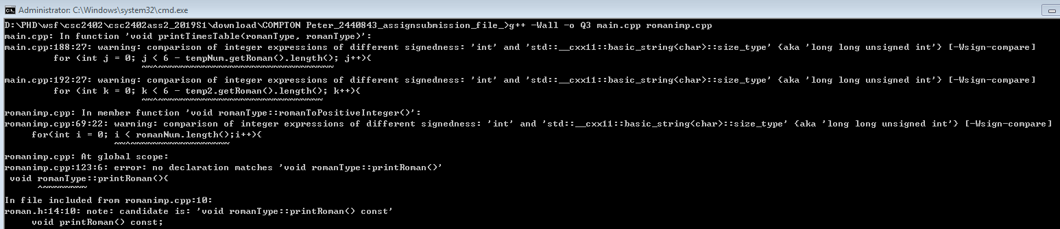

Do not modify the header file for the class.